

Economics (Part 2)

Course Summary

Marc Delingat

delingat@yahoo.com
http://www.geocities.com/delingat

Table of Contents
Table of Contents 2
Course Summary 3
Module 11: Macroeconomics Overview 3
Module 12: Potential Output 5
Module 13: The Circular Flow of Income 7
Module 14: A Simple Model of Income Determination 9
Module 15: Expanded Model of Income Distribution 12
Module 16: Fiscal Policy 15
Module 17: Money, the Central Bank and Monetary Policy 17
Module 18: The Quantity Theory and the Keynesian Theory of Money 19
Module 19: Integration of the Real and Monetary Sectors of the Economy 21
Module 20: Inflation and Unemployment 24
How to Modify the Document to Suit your Needs 26
Thanks and Revision History 26

Course Summary

Module 11: Macroeconomics Overview

Full employment is defined as a percentage of people in the labor force being employed for an expected number of hours peer week for an expected number of days in a year, taking into account recognized holidays. The full employment rate of unemployment (also called the natural rate of unemployment) is dependent on socio-economic factors and differs for each nation. Each nation also has a related full employment rate of downtime (or unused capacity) for factories and machine tools.

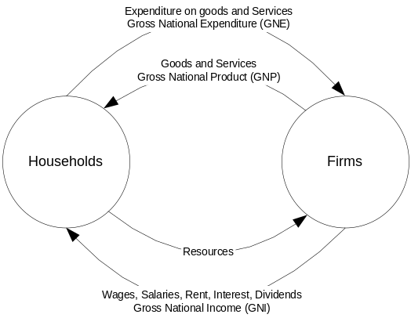

In this simple model GNP=C+I and GNI =C+S. Therefore investment (I) has to be equal to household savings (S).

Gross National Product (GNP) for all groups (the aggregate demand)
C is Consumer Expenditure
I is Investment Expenditure
G is Government Expenditure
X is Exports
Z is Imports
This equation is also called the national income identity

Governments try to alleviate the effects of the cyclical tendencies of a nation’s economy. They aim at keeping aggregate demand stable. The following factors make this difficult:
- Policy tools at the governments disposal act with a time lag
- Potential output (Q) normally increases constantly due to
  - Growth in the quality and quantity of labor
  - Growth in the quality and quantity of capital stock
  - Technological advances
- Household and companies expenditure patterns are hard to predict
- Exogenous shocks (outside events) influence the economy

The government has tools in the following two areas at it’s disposal:
Monetary policy involves control over the supply of money, which directly affect the interest rates.
Fiscal policy involves control of government expenditure and tax rates.

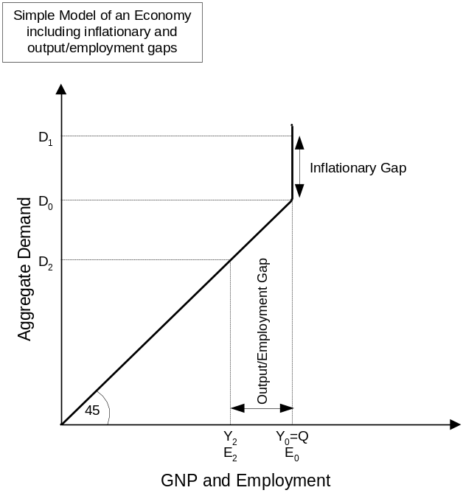

At D₀ the economy is operating at full employment and the actual output Y equals the potential output. If the demand increases to D₁, the economy comes under inflationary pressure due to the inflationary gap when prices for goods and services are able to rise but the output can not increase to meet demand at current price levels. If the demand decreases to D₂, the economy operates at less than the full potential output Q and unemployment and an output gap is the result. Due to the fact that wages are usually not adjusted downwards (due e.g. to union contracts) if the demand for labor decreases, but wages increase if the demand exceeds supply, the economy as a whole has an inflationary bias.
As noted above the potential output (Q) will grow over time because of the mentioned supply side factors generally outside of the control of the government. Thus the government has the following tools to expand/reduce demand over time:

Fiscal Policies:
- Increase government expenditure (G): an increase in G will lead to an increase in Y that is proportionally larger than the increase in government expenditure due to the ripple effects on increased spending. The government expenditure multiplier is the ratio of total change in Y to the initial change in G.
- Reduce taxes: Y is not directly increased. Rather the disposable income is increased as the government collects less tax. The additional disposable income is then spent resulting again in the multiplier effect described above.

Monetary Policies:
- Increase the money supply: Increasing the money supply faster than the demand for money will result in a fall in the price of money; the price of money is the interest rate (R). Firms and households consider the interest for a loan as part of the price of making a purchase (cost of capital). Thus if the interest rate goes down the cost for a purchase goes down with it, which will lead to increased demand and more goods being produced and sold.

Which tool the government should use depends on the other macroeconomic goals a nation has. To purely close the output gap or reduce the inflationary gap all above tools would work. Generally desirable macroeconomic goals are:
- Low inflation rate
- Low unemployment rate
- Balanced government budget
- A positive balance of trade
- A stable currency in international exchange markets

Module 12: Potential Output

Classification of Resources:
- Capital Goods
  - Land: all natural resources including agricultural land, rivers, forests, climate and mineral deposits
  - Capital: all factories, warehouses, offices, equipment, materials, houses, universities, etc. that have been produced in previous time periods
- Labor Force
  - Labor: the proportion of the population that is willing and able to work. The quality depends on education, age, hours of work, skills, etc.
  - Enterprise: those individuals in the labor force with organizational and managerial ability or financial skills, such as individuals taking risks in starting new companies and launching new products with own or borrowed resources.

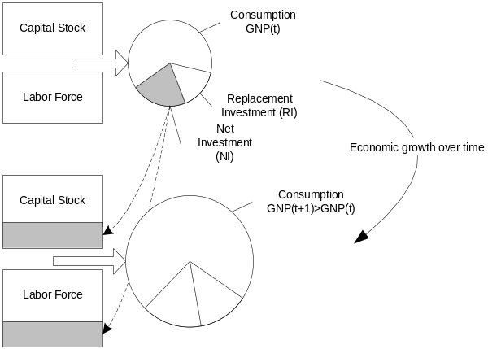

If a society would consume all resources produced they would not be able to consume as many resources in the future as no resources would be available for replacement investment that is necessary to compensate for the reduction in productivity in the capital stock and labor force due to e.g. wear on machines, retirement, etc. If the net investment (gross investment minus replacement investment) is positive the stock of input increases and so does the productive potential of the economy.

The production possibility frontier shows the possible combinations of production of capital and consumption goods at a given time (with a given capital stock, labor force, technology, etc.).

Doubling the output (rule of thumb): 72 divided by the (GNP) growth rate gives the number of years it takes to double the output (GNP).
Estimating potential output: most widely used measures of utilization of factors of production are unemployment rate and capacity utilization (through industry surveys).

Types of unemployment:
- Frictional Unemployment: People currently switching jobs. Caused by imperfect information in the labor market. Frictional unemployment exists even in an economy where actual output equals potential output.
- Structural Unemployment: “Long-term” frictional unemployment. Caused by a mismatch in the characteristics of the unemployed and the job vacancies (skills, location).
- Seasonal Unemployment: Occurs in areas where production levels are dependent on weather or calendar events.
- Demand-Deficient Unemployment: Caused due to insufficient demand for labor.

Okun’s Law
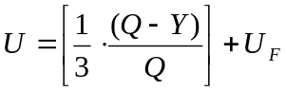
U: Unemployment
U_{F}: Full employment rate of unemployment (natural rate of unemployment)
Y: Actual output
Q: Potential Output

The inflation rate is the percentage increase per year in the average price level from one time period to another.
The consumer price index (CPI) measures the average price level of goods and services for a typical household.
The index that includes all goods and services produced in an economy is called the GNP deflator. It is calculated similar to the CPI.

How do firms set prices? They use the expected demand and expected costs to decide the price. In order to determine those firms use their own recent experience and what happens to the economy as a whole. Of importance for both is the recent level of aggregate demand.

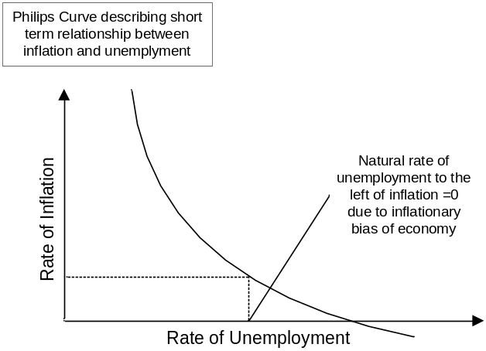

The Philips curve describes a short-term relationship. The Philips curve can shift over time. Economic analysis cannot determine which point on the curve a society deems acceptable, it can only analyze the trade-offs between inflation and unemployment and can indicate how an economy can be moved along the curve.

Module 13: The Circular Flow of Income

Net National Product (NNP) sets the limit to consumption that does not entail the penalty lower level of output and consumption in the future.

Net National Product

Only final goods and services are included, intermediate goods and services are excluded from the calculation. Intermediate goods and services are used up in the production of the final goods and services.

GNP can be calculated by finding:
- The expenditure on final goods and services (GNE)
- The value added by each producer
- The total income earned by each factor of production (GNI)

The value added by a producer is the value of the output of the firm (sales) in a given period less the value of the inputs (total purchased intermediate goods) used in production.

The sum of payments by a producer for intermediate goods and for primary factors of production equals total receipts from sales of output. Therefore a producer’s value added is equal to the sum of payments to primary factors.

For a receipt to be included in the national income it must be used in return for the use of a factor of production.

Income can be classified as:
- Wages and salaries – paid in return for the use of labor
- Rent – paid in return for the use of land and capital goods not owned by the producer
- Interest – paid to the households who have loaned money to purchase land and capital
- Gross profits – residual accruing to the firm after all payments of wages, salaries, rent, and interest have been made

Consumption (C): expenditure on goods and services to satisfy current needs
Savings (S): income not spent on consumption
Income (Y): comprised on Consumption and Savings (Y=C+S)
Investment (I): is the production of goods that are not used for consumption purposes; these goods are known as investment goods. Main categories of investment goods are:
- Inventories: stocks of inputs and outputs of production. An increase in inventories represents additional investment, a reduction disinvestment. Changes in inventories can be planned (e.g. to ramp up production) or unplanned (e.g. unexpectedly low sales).
- Capital goods

Investment
Gross Investment (I) = Replacement Investment (RI) + Net Investment (NI)

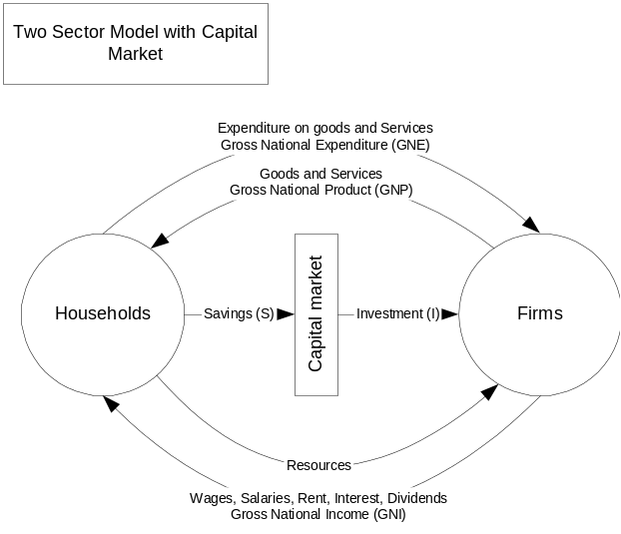

A withdrawal is any part of the income of private households that is not passed on to the circular flow of income. It has a contradictory effect on the level of national income.
An injection is any addition to the income of domestic firms that does not accrue from the expenditure of private domestic households. It has an expansionary effect on the level of national income.
If savings (S) and investment (I) are unequal, a change in the level of national income will occur. The economy is only in equilibrium if S=I. The motives of savers and investors being different, there is no guarantee that the plans of savers and investors will be consistent in the short run at all levels of income. For this reason the national income realized can and does depart from the full employment income.

Module 14: A Simple Model of Income Determination

In an economic model, the exogenous variables are determined externally. The model itself describes the behavior of the endogenous variables.
Keynes’s assumption for the simple model of income determination and GNP: Price is an exogenous variable; this is a reasonable assumption in the short term as prices are already determined by past events.

Disposable Income
Disposable Income (Y_{D}) = Income (I) – Taxes + Transfers

The relationship between the consumption and income is called the consumption function. Empirical evidence suggests that households increase their consumption as their income increases but not as much as their income.

Only if the MPC<1 is the economical model stable, that is if people on a change in input do not increase their consumption by more than the increase in disposable income.

Marginal Propensity to Consume (MPC)
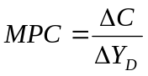
Average Propensity to Consume (APC)
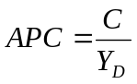
In the short run APC>MPC due to the lag time it takes for a consumer to adjust the consumption to a change in disposable income.

Marginal Propensity to Save (MPS)
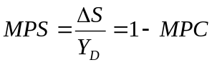

Empirical studies have found that:
- Households with relatively low income will save proportionally less (or even dis-save) than households with a proportionally higher income
- Over long periods as the living standards in a society increase the relationship between consumption and disposable income appears roughly proportional. Consequently, the proportion of disposable income saved has remained fairly stable over long periods of time.
- While the long-run relationship has been historically stable, the relationship between short-term changes in income and changes in consumption is less predictable. In the short-run the change in consumption tends to lag the change in income.

Short Run Consumption Function
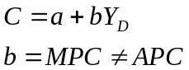
Long Run Consumption Function
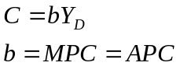

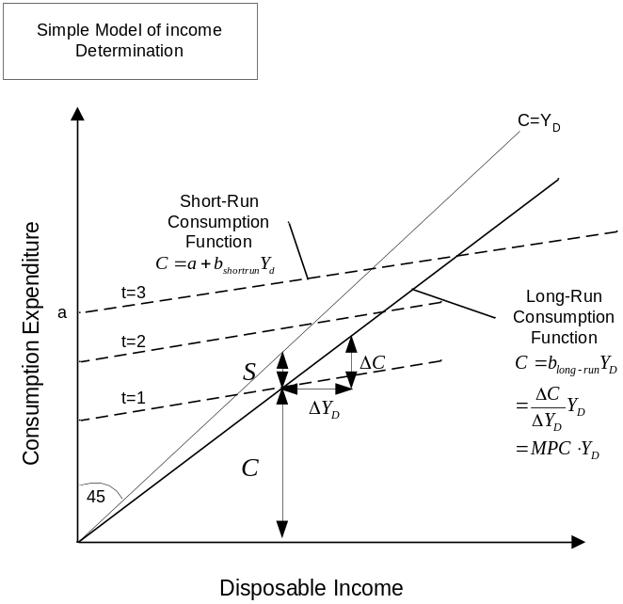

A shift in the consumption function curve indicates that the amount consumed is different at each level of income, the direction of change dependent on whether the consumption function shifts upward or downward. A shift can be caused by a change in factors other than the income, which leads to a change in the whole function.
A movement along the consumption function curve indicates the changes in consumption that are a consequence of the changes in income. A movement along the consumption function is caused by only changes in income (cet. par.).

Simple Model
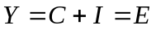
National Income is determined by the sum of consumption and investment expenditures resulting in aggregate demand (or aggregate expenditure)
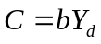
Consumption is a function of income, APC=MPC=b. Y=Y_{d} as there is no government sector
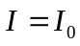
The level of investment is fixed exogenously (outside the model)

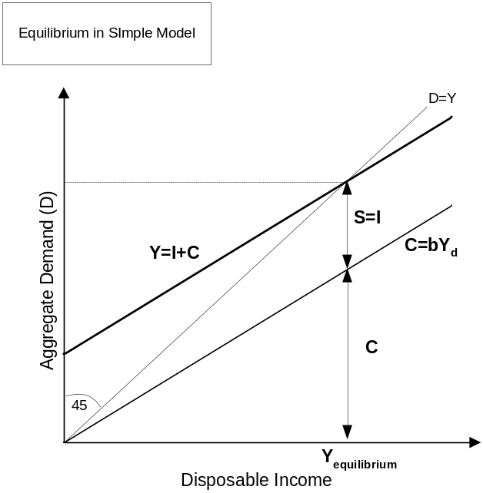

Where the aggregate demand (expenditure) function lies above the 45° line aggregate demand is more than the national income, below it is less. At aggregate demand = national income, I=S and the model is in equilibrium.

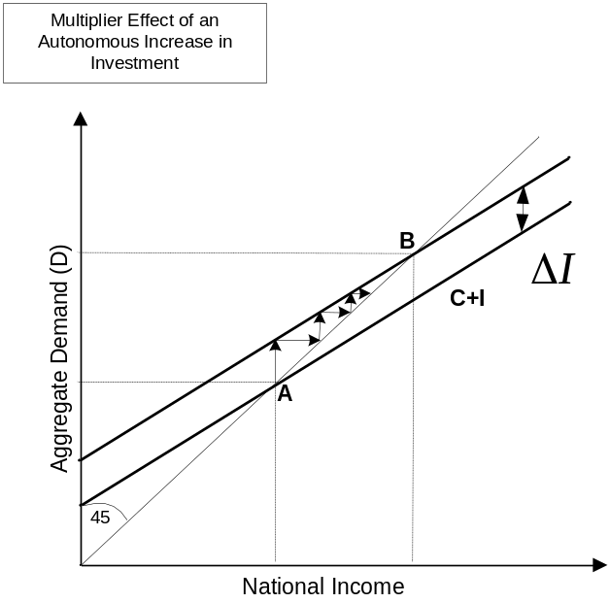

An autonomous increase in aggregate demand (e.g. through increase of investment) has a multiplier effect in the national output and income.

Multiplier for Autonomous increase in investment (or demand)
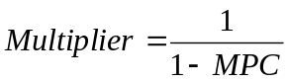
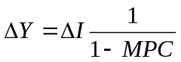 in this case the investment multiplier

For the multiplier process to work it’s way to completion, there has to be
- sufficient unemployment. If the economy were to operate at full employment any autonomous increase in demand would result in inflation as the output Y has reached the potential output. The remaining demand creates and inflationary gap.
- an MPC between 0 and 1. In the real world calculating the multiplier is very difficult. It therefore is not easy to guide the economy to full employment.

Module 15: Expanded Model of Income Distribution

Investment expenditure is proportionally less than consumer expenditure but it is generally more volatile, thus has a big influence on short-term behavior of income and output.
Investment decisions are grounded in expectations about the future (e.g. expected rate of return) and thus prone to uncertainty.
Factor to consider when making an investment:
- The cost of the investment
- The expected return from investment in the form of increased income
- The cost of financing the investment (real or opportunity cost)
The first two factors give the rate of return over cost or marginal efficiency of investment (MEI). The third factor is the rate of interest (R).

Compound Interest
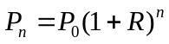
P: Principal
R: Rate if interest (interest rate) per time period
n: number of time periods

Present Value
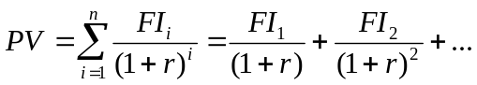
PV: Present Value of a future investment
FI: Future Investment in time period I
r: rate of discount (discount rate) per time period
n: number of time periods

At a given level of technical knowledge the marginal efficiency of investment will decline as the volume of investment increases. However, there is no convincing evidence that the rate of return over cost has declined throughout time primarily because technical knowledge improves through time.

When to pursue an investment project? It is only rational to undertake an investment project if the marginal efficiency of an investment (r) is higher than the interest rate (R), as only in this case the return on investment is higher than the opportunity cost.
As the marginal efficiency of investment decreases with the increase of investment, the volume of investment will be lower as now the opportunity cost outweighs the investment return.

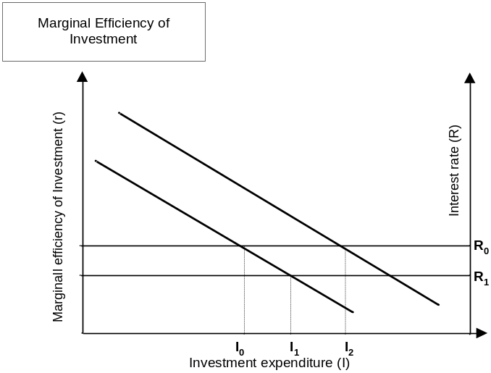

If the rate of interest (R₀) is lowered (to R₁) the opportunity cost decreases and thus the level at which the marginal efficiency of investment is reasonable is lower, resulting in an increase in investment (I₁). If e.g. the managers of the company become more optimistic, e.g. through reduced uncertainty in predicting the investment return, the whole marginal investment efficiency curve shifts to the right resulting also in an increase in investment.

Another factor that contributes to the fluctuation in investment is that some of the investments are determined by the rate of change of national income/output; this is known as the accelerator principle. The accelerator in principle states that if the capital-output ratio is greater than unity, the increase in net investment to reach an increase in sales will always be bigger than the increase in sales. In other words, it takes an investment of $4 to increase sales by $2 (the capital-output ratio is 2).

Accelerator Coefficient or Capital-Output Ratio
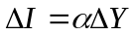
α: Accelerator Coefficient of Capital Output Ratio

Accelerator principle vs. multiplier effect for investment expenditures: Changes in investment through the multiplier process have secondary effects on the income. Changes in income (and thereby demand) due to the accelerator effect have effects on changes in investment. The two effects reinforce each other (during increases as well as decreases of investment and income).

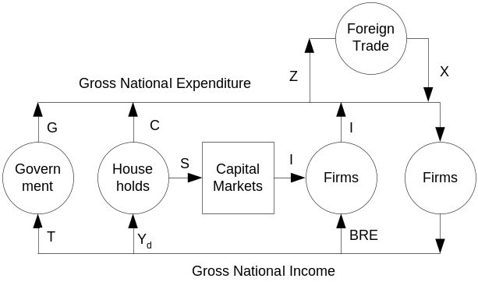

BRE Business Retained Earnings
I Investment
Y_{d} Disposable Income
C Consumption
S Savings
Z Imports
X Exports
T Net Taxes (= Taxes – Government Transfers)
G Government Expenditure excluding transfer payments

Gross National Expenditure, Income, and Product
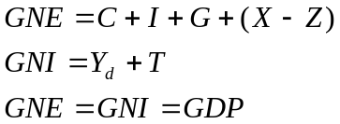

Expanded Model of Income Determination (without BRE)
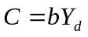
Consumption is proportional to the disposable income of the households
b: (long range) marginal (equal to average) propensity to consume
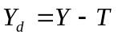
The disposable income is the national income (=GNI) minus taxes and retained earnings
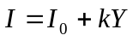
The investment is a function of a exogenous investment I₀ and a component that is related to the level of income
k: marginal propensity to invest
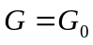
Government expenditure is exogenous to the model
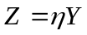
The imports are dependent on the national level of income
η: the marginal propensity to import
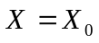
Exports are exogenous and are determined outside of the model
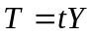
This equation describes the tax rate for a constant tax (not progressive)
t: tax rate

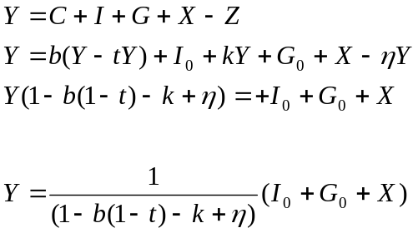

The nature of the governments system of taxes and expenditure creates a system with certain automatic stabilizers. The most important of them are:
- Taxes (e.g. income tax, sates tax, taxes on corporate profits)
- Transfers (e.g. unemployment benefits)
- Price supports (e.g. minimum prices guaranteed for agricultural products)
Monetarists believe that the system should rely on build in stabilizers that discretionary fiscal policy aggravates rather than reduce the fluctuations in economic activity. The aim of fiscal policy in their eyes should be a balanced budget at the highest level of unemployment that is consistent with price stability.
Keynesians believe that discretionary fiscal policy is needed for a stabilizing influence.
There are situation (e.g. high unemployment or high inflation) in which both sides would agree that the built in stabilizers are undesirable as they might prevent the economy from returning to full employment.

Gross profit of a business consists of the following components:
- Capital consumption allowances (depreciation): income necessary to cover the cost of depreciation of capital goods used in production
- Undistributed Profits (business retained earnings), a part of net profits
- Dividends, paid to owners and shareholders

Complete Model of the circular flow of income:
Disposable personal income = wages, salaries, rents, interest + dividends – taxes + transfer payments
Business Retained Earnings = net profit + capital consumption allowances – direct business taxes – dividends
Net taxes = indirect business taxes + direct business taxes + personal taxes – transfer
payments

Module 16: Fiscal Policy

The insufficiency of aggregate demand compared with the level of aggregate demand necessary to obtain and sustain Y_{full} is known as deflationary gap. The excess aggregate demand over and above the level of aggregate demand necessary to obtain and sustain Y_{full} is called inflationary gap.

If aggregate demand is just sufficient to maintain (full) capacity output, then full employment and capacity income would result (Y_{full}).

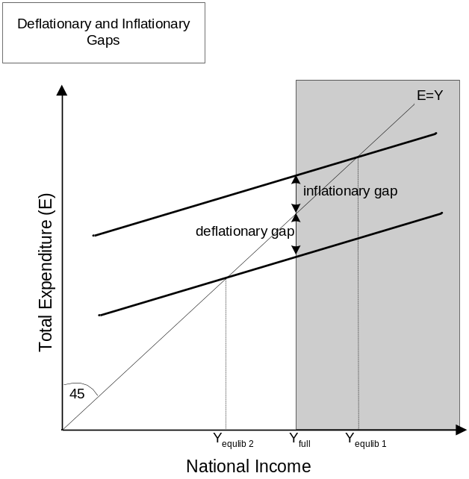

At Y_{equlib 2} (Expenditure = Income thus the economy is in equilibrium) the equilibrium income is less than Y_{full} and not all factors of production are employed.
At Y_{equilib 1} the economy would be in equilibrium to the right of Y_{full}. How is that possible, as Y_{full} signifies the economy at full capacity? Since 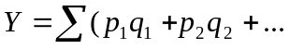 that is the quantity is weighted by the price, any growth of national income Y past Y_{full} has not changed the actual quantities of the goods, but only the price(s), thus the trend towards inflation this scenario (the real national income stays at Y_{full}).

Money income is measured by the price weights currently ruling. Real income measured by adjusting for changes over time in the value of the measuring unit (money). A price index is calculated by selecting a ‘typical basket of goods and services’, observing the price changes of these goods and services and weighting the price changes to allow for the different economic importance of the goods and services. The price index used to obtain the real GNP from the GNP in money terms is called the GNP Deflator.

A fiscal policy of functional finance means that there is no single automatic rule that should be followed regarding the relationship between government expenditure (G) and government taxation (T). Discretionary fiscal policy should adjust the relationship between G and T to drive the economy to full capacity and full employment.

The crowding out effect takes place if raising of G relative to T would not result in a higher aggregate demand, in that higher government expenditure would be at the expense of lower private expenditure (at full capacity of the factor of production the crowding out effect will be 1 (fully effective))

Simplistic Keynesian View | Simplistic Monetarist View
The components of aggregate demand (C, I, G, X) are independent of each other, meaning that a change to one does not directly impact any of the others.  Specifically that an increase in G does not have an adverse effect on any of the others. Thus a budget deficit created by raising G relative to T will increase aggregate demand to the full extend of the increase. | The components of aggregate demand are interdependent, so that changes in the budget deficit (surplus) are offset by equivalent changes (in the opposite direction in the other components of aggregate demand.
Crowding out effect is 0 | Crowding out effect is 1

Budget deficits (G>T) will have an expansionary effect on the economy as the government adds more to the circular flow of income than it adds. Budget surpluses (G<T) will have a deflationary effect on the economy.

Effect of fiscal policies on the aggregate demand in the order of effectiveness:
- An increase in government expenditure G of $1 will result in an increase in aggregate demand less the government’s propensity to import.
- The result of a tax reduction in $1 will depend on the public’s marginal propensity to save plus it’s marginal propensity to import. It is likely that the sum of these two marginal propensities is higher than the government’s propensity to import. In that case a raise in government expenditure by $1 will raise aggregate demand more than a reduction in taxes of $1.
- It follows that a balanced budget does not have a neutral effect on the circular flow of income as $1 of government expenditure creates more aggregate demand than raising taxes by $1 reduces.

Module 17: Money, the Central Bank and Monetary Policy

Money exists in three different types:
- Coins
- Notes
- Bank deposits

Money has the following functions:
- A medium of exchange
- A unit of account
- A store of wealth

For money to function as the medium for exchange it has to have the following characteristics:
  - Widely acceptable
  - High value/weight ratio
  - Divisible in order to settle debts of different denominations
  - Not easily produced, counterfeited, or debased in value

Cloakroom Banking is the banking system in which the bank purely acts as a store for the safekeeping of wealth, but does not contribute itself to the money supply.
Fractional Reserve Banking is a system where the deposit liabilities exceed the bank holdings of cash (formerly gold). Fractional reserve banking depends on the banks ability to maintain confidence and convertibility.
Under fractional reserve banking banks are under influence of two competing pulls:
- The pull of profitability: cash earns no interest, so the bank is interested in lending out the cash and convert it to interest bearing accounts.
- The pull of liquidity: the banks have to keep sufficient cash on hand in order to satisfy the demand of their customers for cash.

A bond is a legally enforceable obligation to pay cash to the bearer, normally issues by a government or company. A bond has a redemption date and a redemption value specifying the cash amount and the date on which the issuer pays the bearer. Usually the bond also has a coupon payment, which is a specific sum of money that has to be paid by the bond issuer yearly. The purchase price of a bond is determined by demand and supply in the market.

The investment multiplier (k) gives the change in Income (Y) as a result of a change in Investment (I)
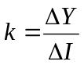
The credit multiplier (d) gives the change in deposits (D) as a result of a change in cash reserves (C).
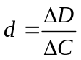
The cash ratio (r) is the percentage of cash (compared to interest bearing assets) that a bank holds as part of the overall assets. The credit creation multiplier is 1/cash ratio (r). The (potential) increase to the money supply ΔM by an initial deposit of X is X times 1/r (the credit creation multiplier).

The creation of bank deposits is limited by:
- The banks propensity to keep cash for liquidity purposes (as represented by the cash ratio)
- The public’s propensity to hold cash (when the propensity to hold cash is high, more cash is not returned to a bank)
The function of a central bank is to control the commercial banks around it in a way as to support the monetary policies of the economy. It acts as
- the banks’ banker,
- lender of last resort,
- the government’s bank, and
- the manager of public debt.
The central bank controls monetary policy by regulating the supply of money and the cost and availability of credit. One way to control the supply of money is by buying and selling bonds in the open market: by buying bonds the central bank increases the money supply and lowers the cost of borrowing, by selling bonds it decreases the money supply and increases the cost of borrowing.
Through changes in the money supply and the cost of money the central bank can influence aggregate demand and consumption (mostly in consumer durable goods) thus income, etc. For example if the interest rates are lowered, investment projects that were previously unprofitable are now viable and will be undertaken. The steps are summarized as follows:

Open Market Operations of the Central Bank
Expansionary | Contractionary
Buy bonds | Sell bonds
Cash reserves of commercial banks increase | Cash reserves of commercial banks decrease
Bank deposits increase | Banks deposits fall
Credit easier and cheaper | Credit difficult and expensive
Aggregate demand rises | Aggregate demand falls
Income increases | Income falls

Instruments of a Central Bank:
- Monopoly of Note Issue
- Ability to dictate cash ratio for commercial banks
- Ability to set reserve requirements for commercial banks
- Ability to set credit controls (e.g. the level of initial payments and repayment periods on hire purchase contracts)
- Ability t issue direct instructions to commercial banks and other financial institutions
- Ability to control open market operation (e.g. buying and selling of government bonds in the open market)

Hire purchase is a form of credit. The customer agrees to buy goods from a supplier/retailer and to pay for those goods in installments. The customer has the right to possess and use the goods from the time the contract is made. The supplier or the finance company keeps ownership of the goods until all payments are completed. Until the contract is completed the customer cannot sell the goods without the knowledge and agreement of the finance company.

The banks are in the business of lending money (extending credit) and are thus actively involved in transacting in hire purchase contracts. The central bank can manage monetary policy by putting controls on the banks lending activities, which obviously includes hire purchase contracts.

Module 18: The Quantity Theory and the Keynesian Theory of Money

The Quantity Theory suggests an immediate and close link between the money supply and the aggregate demand. Keynesian theory suggests that the change in the money supply only influences the securities (e.g. bond) market directly and that only the resulting changes in the interest rate will then influence the aggregate demand.

The Quantity Theory of Money

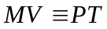
Monetary side ≡ Commodity side

M: money supply
P: level of prices
V: velocity of circulation (number of times a given unit is spent in a certain time period)
T; number of transactions in a certain time period

‘Naïve’ Quantity Theory: If the number of transactions (T) is regarded as proportional to the level of national income (Y), they can be substituted. If one then assumes that V is constant and Y (at full employment) at the equilibrium point is also constant, it follows that: 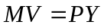 and thus that the relationship between money supply and prices is linear (higher money supply, higher prices).

Modern Quantity Theory: Changes in the money supply can influence prices as well as the level of income, the effect on those two variables being dependent on how far the economy is from full employment.
Substantial unemployment: Increase M, household and firms have more money than they need for transactional purposes and will spend excess, leading to more demand, more income, more output, more employment.
No unemployment: Increase in M, household and firms have more money than they need for transactional purposes and will spend excess, since there is no spare capacity only the prices will go up.

The Quantity Theory does not predict short-run changes in the economy because all four variables of the equation can change.

There are three types of demand for money:
- Transactions Demand for Money: money held to finance current transactions. Needed to bridge the time gap between receipt and expenditure of income. Demand is closely related to:
  - Level of national income (Y) (high income, high demand for transactional money)
  - Price levels (higher prices demand more money in order to finance transactions, thus there is a positive relationship to the inflation rate)
  - Interest Rate (if the interest rate is high firms and households will try to minimize the amount of transactional money in favor of interest bearing)
- Precautionary Demand for Money: money held to meet demand in the sudden arrival of unforeseen circumstances. Demand is related to:
  - Level of national income (Y) (high income, high demand for precautionary money)
  - Interest Rate (if the interest rate is high firms and households will try to minimize the amount of precautionary money in favor of interest bearing)
- Speculative Demand for Money: money kept in cash in order to take advantage of developments in the capital market. Households and firms will hold some percentage of the wealth in cash in order to finance investment transactions. The ‘liquidity preference is not absolute’ as cash does not yield any interest. Demand is related to:
  - Level of national income (Y) (high income, high demand for speculative money)
  - Interest Rate (if the interest rate is high firms and households will try to minimize the amount of speculative money in favor of interest bearing)

The price of existing bonds and the market interest rate are inversely related. If the price of a bond is expected to fall (central bank or others are expected to sell bonds), it is the same as saying that the expected interest will rise. This is due to the fixed coupon payment and redemption value attached to a bond, and thus only the price of a bond can be changed due to demand and supply in the open market.

Module 19: Integration of the Real and Monetary Sectors of the Economy

The ‘real sector’ comprising of the consumption function and the marginal efficiency of investment and the ‘monetary sector’ comprising the supply and demand for money, interact together to influence the level of national income and the rate of interest. The equilibrium national income (Y) and the equilibrium interest rate depend on simultaneous equilibrium in both sectors. The equilibrium thus occurs if planned savings and planned investment are the same and the demand and supply for money are the same.

The liquidity trap is the floor below that the interest rate does not fall. The liquidity trap exists, because for any interest rate below the liquidity trap rate all the speculative money is held in cash, nothing in bonds, as everybody expects the interest rate to go up.

The liquidity-money (LM) curve developed below shows the relationship between the interest rate and the national income for which the monetary sector of the economy is in equilibrium, given a certain fixed money supply. If the money supply is increased the part of the LM above the liquidity trap is moved to the right. The LM curve is constructed out of the demand for M (transactional and precautionary) related to the national income Y and the demand for M (speculative) related to the interest rate R.

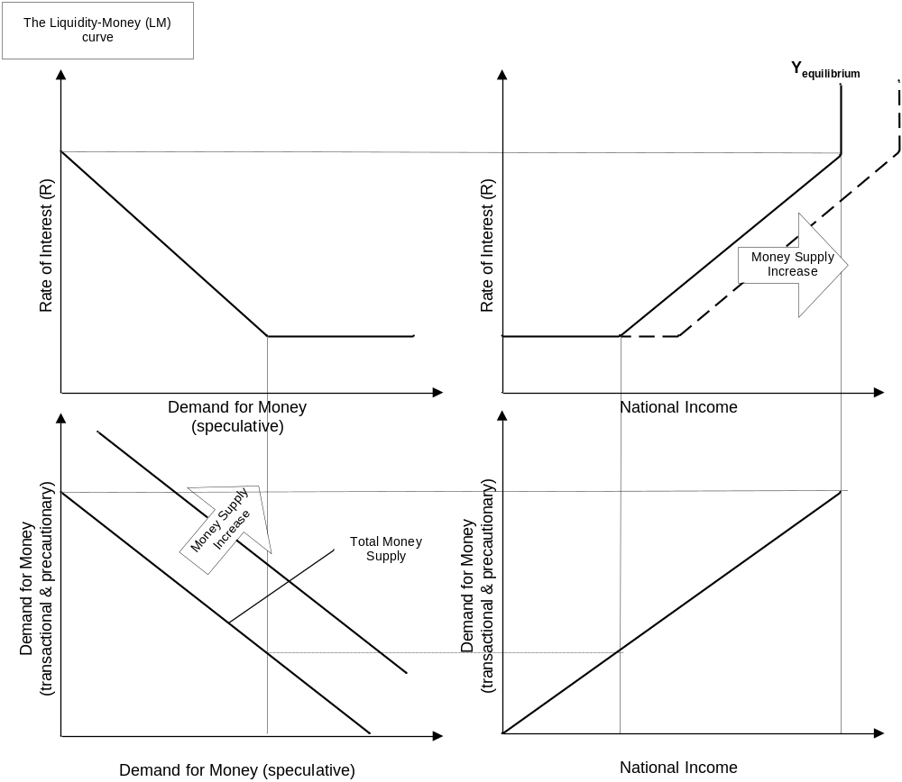

The investment-savings (IS) curve constructed below shows the combination of interest rate R and national income (Y) for which the real goods sector is in equilibrium, that is for which the planned investment of business consistent with the planned savings of households. The IS curve is constructed out of the combination of the consumption function (and this the savings function) (S in relationship to Y) and the marginal efficiency of investment function (I in relationship to R).

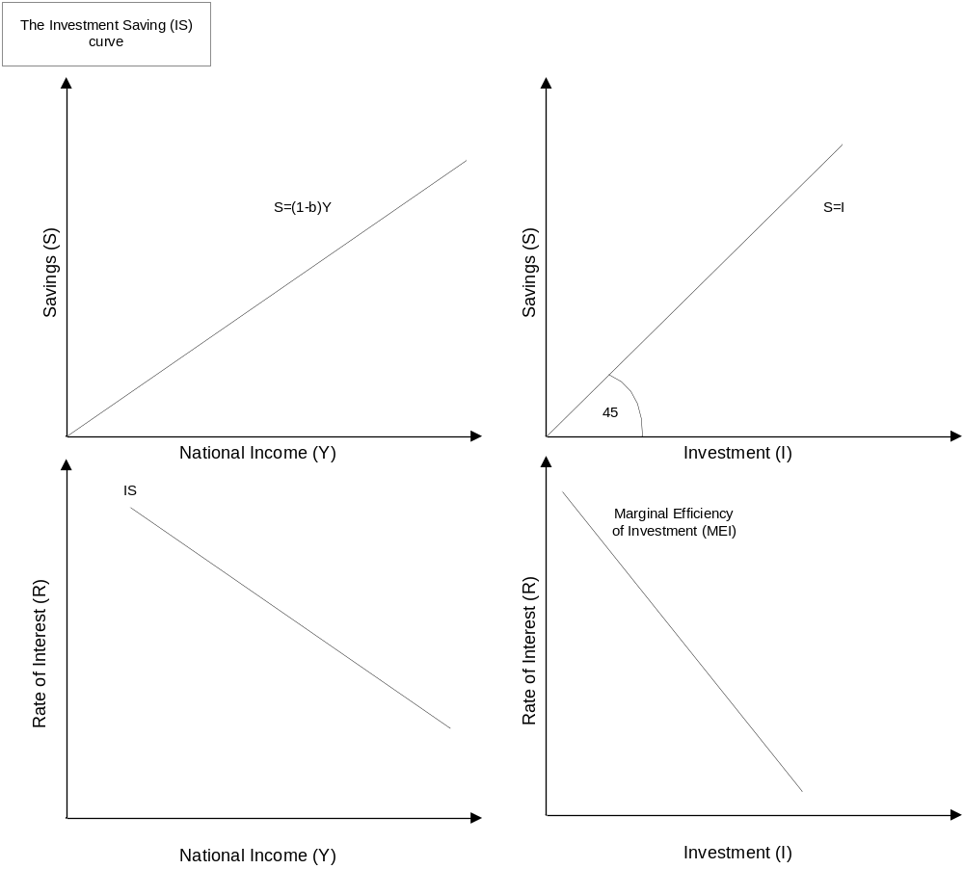

In order to determine the interest rate R and national output Y for which the monetary and the real sectors of the economy are in equilibrium, the LM and IS curves are overlaid. The intersection of the LM and IS curve determines the overall equilibrium.

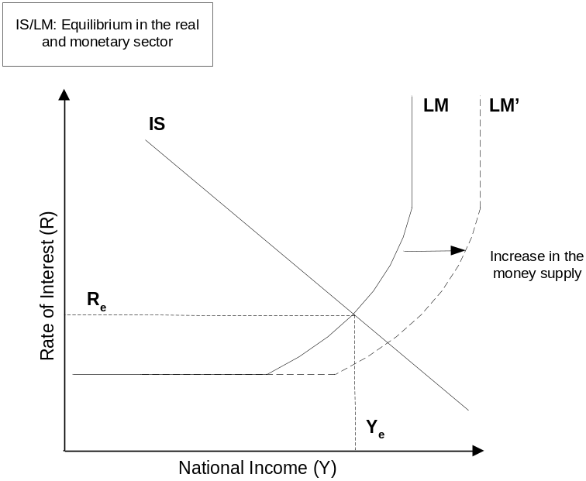

What prevents a market economy from reaching the marginal equivalency condition and thereby economic efficiency?
- New goods and services are constantly introduced to the market
- Factor supplies and prices constantly change
- Technological change
- Exogenous shocks
- Imperfections in the market system:
- public goods
- externalities
- economies of scale
- market imperfections

Module 20: Inflation and Unemployment

Why is price inflation undesirable?
- Inflation impairs the efficiency of the price mechanism and raises the cost of buying and selling because money becomes less reliable as a standard of value.
- Inflation penalizes people on ‘fixed’ incomes and favors those whose money incomes adjust quickly to price changes. The former group includes pensioners, University students, and many salary earners, while most wage and profit earners fall into the latter category.
- Inflation favors borrowers and penalizes lenders as long as it is unanticipated. Thus, if interest rates are fixed, in money terms in the anticipation that the level of prices will remain constant (or the rate of inflation will remain constant), an increase in the prices will reduce the real cost of borrowing.
- Given a system of un-indexed taxes, namely one where taxes are fixed in money terms rather than real terms, inflation will redistribute income from the private to the public sector.
- A continuing higher rate of domestic inflation than experienced in other economies can lead to increased imports and reduced exports and can lead to create potential problems for stable exchange rates.

Demand-pull inflation sees prices rise as a result of excess demand for goods and services, namely that exceeds the capacity output at current price levels. This then also causes the price in the factors of production to rise as firms aim at fulfilling the excess demand.
Cost-push inflation is caused as a result for bargains struck in the factor market, which raise the production costs of employers who pass on the higher costs in the form of higher prices.
In a cost-push inflation model the prices on the market are ‘administered’ by the firms that set them at cost plus profit level. Wages and salaries are ‘administered’ by negotiated agreements. Those administered prices then cause inflation because:
- Trade unions objective to bargain for better pay and money conditions for it’s members
- Highly centralized nature of most trade unions and collective bargaining
- High percentage of wage and salary costs in the total costs of production
Cost-push inflation can only be sustained in the longer term if it is accompanied by a permissive monetary policy. The only way to counter cost-push inflation is to change the framework in which wages and prices are determined. If expectations are the cause of inflation, those have to be changed

Most economies tend to have an inflationary bias because labor costs are adjusted asymmetrically (they increase when demand exceeds supply, but do not decrease significantly if the supply exceeds demand, e.g. due to union contracts). This can be reinforced if coercive comparison is a factor, that is, if employees judge their success by their ability to obtain wage increases matching those in other sectors of the economy (which might have excess supply).

Monetary policy is set to be “permissive” if instead of controlling the money supply to prevent inflation, the monetary authorities condone cost-push inflation by allowing an increase in the money supply and thus allow for higher price levels without imposing costs on employers and employees through lost output and unemployment.

Imported inflation: if the demand for a certain imported good is relative price inelastic (doesn’t change when price changes), a rise in the price of the imported good will be reflected in higher inflation rates.

Expectations inflation: There are three ways to figure expectations into economic models:
- Expectations are static; they do not change over time
- Expectations are adaptive; the expectation change gradually when current expectations have proven wrong
- Expectations are rational; everyone in the economy has and uses the same economic information as the policy makers and bases their expectations on that information

Modern Quantity Theory vs. Keynes

Monetarists | Keynesians
Effect of changes in the money supply on aggregate demand
Demand for money is a stable function of variables i.e. level of income, expected rate of return, rate of changes in prices, etc. while velocity of circulation is near constant. The aggregate demand is therefore directly influenced by the money supply as excess money will be spent thus generating more Y | Changes in velocity my offset changes in the money supply. For example in a depression an increase in M might find it’s way into speculative balances thus reducing V, so that there is no effect on the aggregate demand by M.
Causes of changes in inflation rate
The money supply is independent of the demand. The monetary authority sets the supply exogenously. As aggregate demand increases due to an increase in M, price inflation might result. The price inflation is only a result of a change in the supply for money, while the demand has stayed the same. | The neo-Keynesian view is that the money responds to economic variables and is thus endogenous to the model. The monetary authority, e.g. “underwrites” the inflation caused by rising wages.  It has also been suggested that the monetary authority might not have efficient control of the money supply. Companies might be able to economize on the existing money supply.

Both agree that a high rate of inflation can only be sustained if the money supply is expanded significantly.

How to Modify the Document to Suit your Needs

The drawings in this document were produced using Microsoft Visio 2002. The file with the original drawings is called “Economics Course Summary Visio Diagrams” and is located at the same place where you fond this document. In order to change any drawings you can either double click on the drawing itself in the word document (opens Visio inside of Word, usually slow and not recommended) or you can find the drawing in the Visio file, edit it there and then copy and paste it back into the word document.

Thanks and Revision History

The material in this document is obviously reproduced from the Economics course text of the Edinburgh Business School. It was intended to aid me in understanding the course content, prepare for the exam, and serve as future reference. I have included in various places material from past exam questions as well as comments from fellow students that answered my questions on the “Watercooler” (http://forums.delphiforums.com/hwmba/start). Many thanks to those who make the watercooler an invaluable study help. If you find any errors, omissions or have any other suggestions for improvement, please don’t hesitate to contact me at delingat@yahoo.com.

Revision History
Version 1.0 on June 25, 2002

